The Unicorn

Its name:  It lives:  Its birthday:  Age:  Brothers/sisters:  Favourite food:  Favourite drinks:  It likes:  It doesn’t like: | 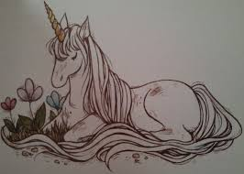

Write about your unicorn: __________________________________________________________________________________________________________

_______________________________________________________________________________________________________________________________

_______________________________________________________________________________________________________________________________

_______________________________________________________________________________________________________________________________

Készítette: Ráczné Pincési Julianna

