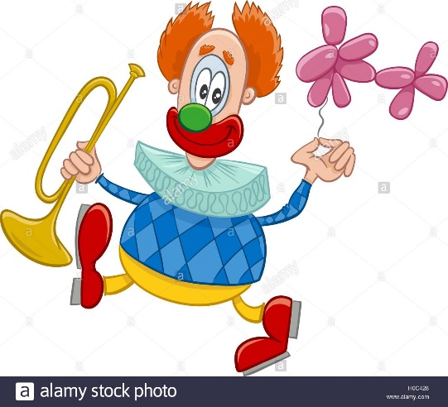
” When I am at the circus ” – Vocabulary building worksheet
(p. 34, by Sz.-Pifkó Célia)
- Find the Hungarian pairs of the following words in the text. Then write them down.
lollipop –
ringmaster –
acrobat –
animal trainer –
juggler –
magician –
clown –
conjurer –

2. Solve the word search and look up the meanings of the given words in a dictionary.

COTTON CANDY, HOOP, LION TAMER, MAGICIAN, MONKEY, POGO STICK, STILT, TENT, TICKET

B F J P Q M H Y D K Y S N E K
O O O N O I J V Y D O J M V C
B O J N P S I L N B J O A L E
H C K K D T Q A L F E R G L Z
U E L M N S C A P P B G I T E
Y I V I O N B Y S V J Q C N V
I Q Z P O G O S T I C K I E W
E K V T Z N T E K C I T A T I
A E T P P W T O U H L M N O N
E O E L T I B A T R U Z G R J
C Q J K I O Q B M K S W P I I
X Y A I B T E U V E F E N T K
U F H G B K S D U Q R O D N R
X C X T D E T G U A D T R M L
V P P U C F P K N I K S U I E

