The Royal family

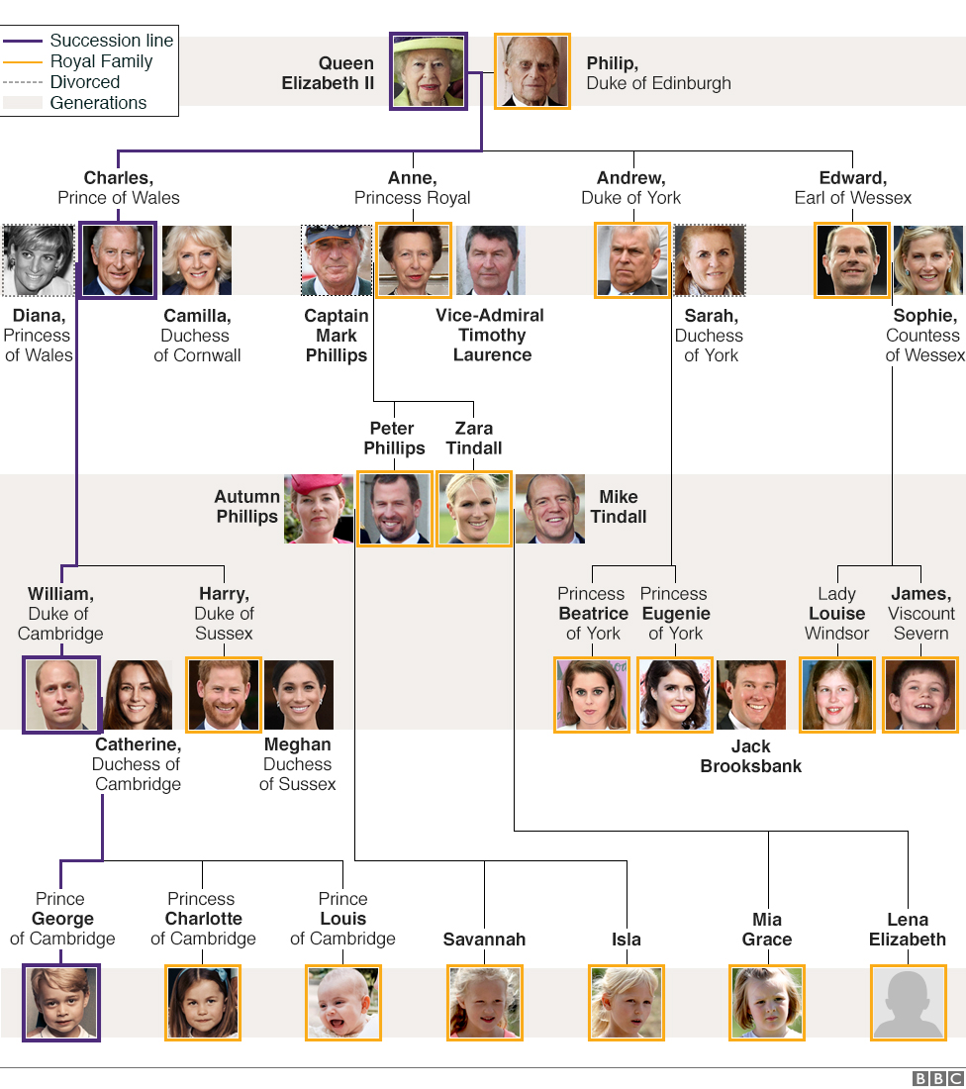
Kép forrása: https://www.bbc.com/news/uk-23272491

- Answer the questions about the Royal family.
- Who is Beatrice’s mother?
- Who is Edward’s sister?
- Who is Anne’s daughter?
- Who is Andrew’s mother?
- Who is Mark Philip’s son?
- Who is Charlotte’s grandfather?
- Who is Harry’s brother?
- Who is Savannah’s great-grandfather?
- Who is Louise’s aunt?
- Who is Edward’s wife?

- Translation.
- Andrew-nak két lánya van.
- Peter anyukáját Anne-nek hívják.
- Erzsébet királynő anyukája is Erzsébet.
- Edward-nak két fiú és egy lánytestvére van.
- Beatrice William unokatestvére.
- Henry nagynénje Anne.
- Isla apukája Peter Philips.
- James nagymamája Elisabeth, nagypapája Philip.
Megoldás:

- Sarah
- Anne
- Zara
- Queen Elizabeth II
- Peter
- Charles
- William
- Philip
- Anne
- Sophie
2.
  - Andrew has got two daughters.
- Peter’s mum is called Anne.
- Queen Elisabeth’s mother is called Elisabeth, too.
- Edward has got two brothers and a sister.
- Beatrice is William’s cousin.
- Henry’s aunt is Anne.
- Isla’s dad is Peter Philips.
- James’s grandmother is Elisabeth, his grandfather is Philip.

