Projekt óra (2x45 perces óra)

Az órák témája: ismerkedés az ökológiai lábnyommal, környezettudatosság, környezetvédelem, állatvédelem, érzékenyítés
Az órák cél és feladatrendszere (fejlesztendő készségek): kreatív gondolkodás, önálló gondolkodás, véleményalkotás, vitakészség, értő figyelem, fordítási készség, logikus gondolkodás, rögzítés
Tantárgyi kapcsolatok: irodalom, nyelvtan, földrajz, biológia-ökológia, vizuális kultúra (rajz)
Az órák didaktikai feladatai: szókincs frissítése, ismeretbővítés, jegyzetelés, memória fejlesztése, empátia, lényegkiemelés, rendszerezés, aktivizálás, visszacsatolás, értékelés
Korosztály: 7. o. – 12. évfolyam (általános és középiskola)

Első 45 perces tanóra (Part 1)

Class Registration
Intro: Today we are going to do something different and have an interactive class. You are going to learn about environment and ecology. 2-3’

Task 1: Let’s play a game with vocab, it is a mindmap exercise, so you need your exercise book. 7’
Please draw a cloud in the middle of the page like this one on the board, write ENVIRONMENT into the cloud, think and write down any word that comes into your mind in connection with environment.
You can also work together with the person sitting next to you to ask for some help with the English meaning/equivalents.
Try to put down more than one word, e.g. a noun, a verb, an adjective or whatever comes to your mind.
You have 4-5 minutes to do your job. (If you don’t know the word I or your partner can help you to some extent.)
Task 2: Okay, let’s see what you’ve got, I’ll put them down on the board.
All your ideas are correct, don’t panic, just say your word.
Okay, another round, tell me more words, please. 5’

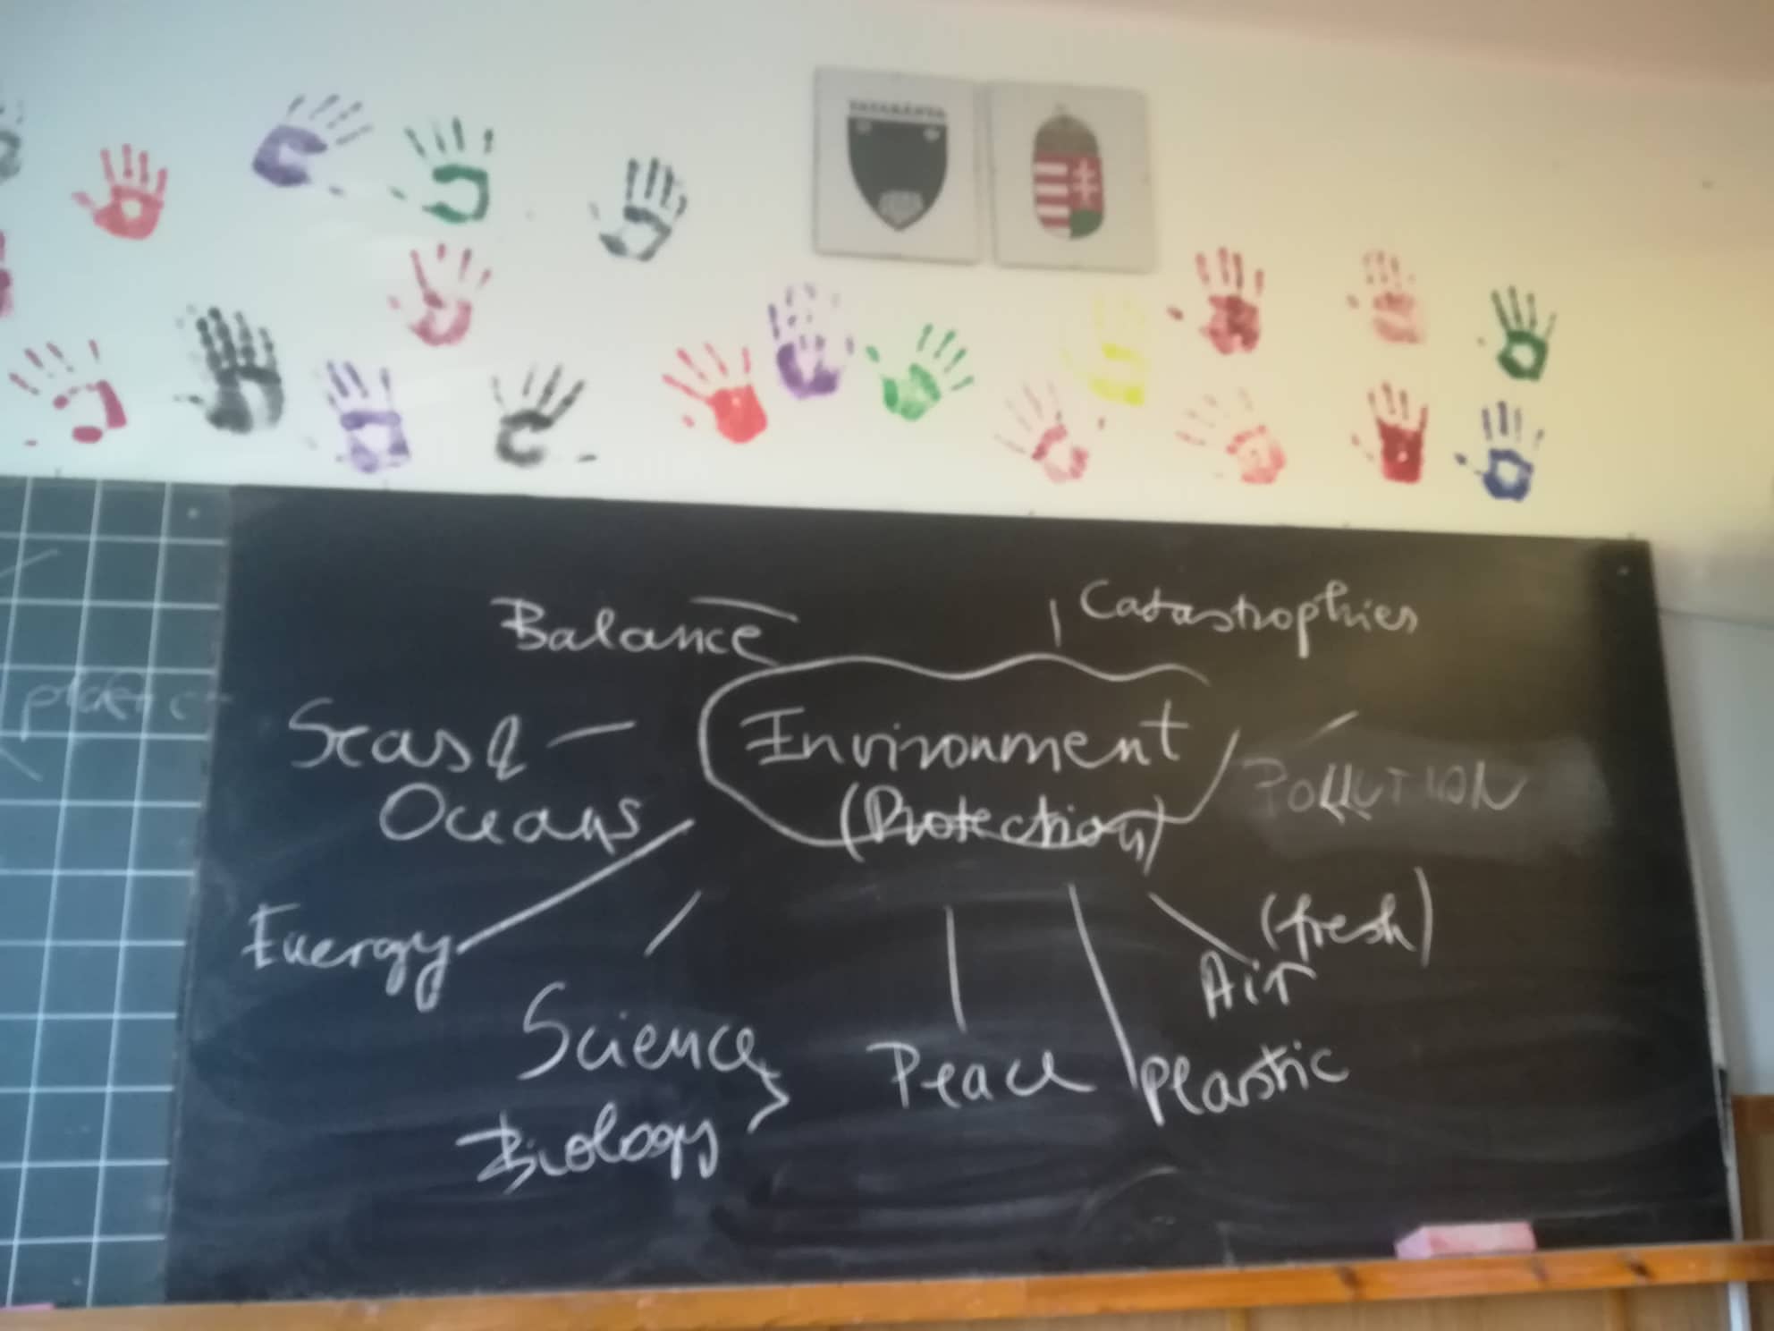

You see you’ve got different notions/words here. There’s no wrong answer.

Task 3: Now please copy the mindmap into your exercise-books from the board. You can use different colours if you like. At home you can make it bigger/expand, you can write more words under each ’category’, but it’s an optional homework. I’ll give you some rewards for doing so. 3’

Task 4: Let’s talk about environmental protection now. How much are you environment-conscious or care about the environment in any way? Please think about it for a moment and choose a category for yourself. 2’
Where would you place yourself and why? Support your ideas with some examples, like what you do at home, how you save energy and things like that.
I’ll write the categories on the board and I’ll just tick one by one:
0-30%
31-60%
61-80%
81-100%

The actual results were:
0-30% X
31-60% 4 students
61-80% 2 students
81-100% 1 student

Task 5: Let’s listen to each other’s opinion about why they chose the categories
10’
(The answers: Nobody litters in the streets and not everybody collects waste selectively. They don’t care about the environment too much.)

Task 6: Now I’ll give you a copy of an ecological footprint. Do you know what it is? Can anyone explain to the others? So it’s about the resources you use everyday. All sorts of things, like food, water, electricity and so on. These are the keywords but you can think of others, too. 3-4’
Your task is to plan and colour the ratio/portion you use of each: the most, less, the least, like this. You can use colour pens, or pencils if you like. 7’
You may use your mobiles for translation if you like. Okay, your time is up, you can finish colouring at home. No problem with extra sheets. You can bring them back for next time just to show us. Don’t forget about the extra HW. 3-4’

Második 45 perces tanóra (Part 2)

Korosztály: 11–12. évfolyam (középiskola)

Class Registration
Intro: Today we are going to continue the lesson from last time, so it’s going to be another interactive class. You are going to learn about the environment and ecology again but with the help of a poem, this time in Hungarian. 3’

Task 1: You need your exercise-books. I’m going to read the poem aloud two times and slowly, you have to write the words you hear in English. There will be some easy ones, like animals. If you don’t know the words in English, you can put them down in Hungarian. Also, try to translate other words, expressions or just write them down in Hungarian if you have no idea of the English meaning. 2’
Fecske Csaba: Az állatok kiáltványa 3’
Task 2: Okay, let’s see what you’ve got. I’ll write them on the board. Let’s do it one by one, so everybody can say something. Please copy the ones you don’t have. 5-6’
Task 3: As I see, you have some missing words, so let’s work on them together. I would like to hear your ideas first, then I say mine. 7’

Task 4: Now there will be a little bit different exercise about your feelings. I’ll read the poem one more time. How do you feel about the poem or the animals? What’s the situation like for them? You can make notes both in English or Hungarian if you like. I’ll give you some extra time after reading. 4-5’
What’s the poem really about? Now let’s talk about your feelings and the animals’, too. Let’s discuss. 6-7’

Task 5: Finally we’re going to rewrite the poem in English together. All your ideas are welcome. We’ve got all the vocab. 10-12’
(If there is time left: How do you feel about the poem now? Is it any different than before? Talk about your feelings. It’s optional)

