ADJECTIVES

Match the words to the pictures!
The words can match more than one picture.

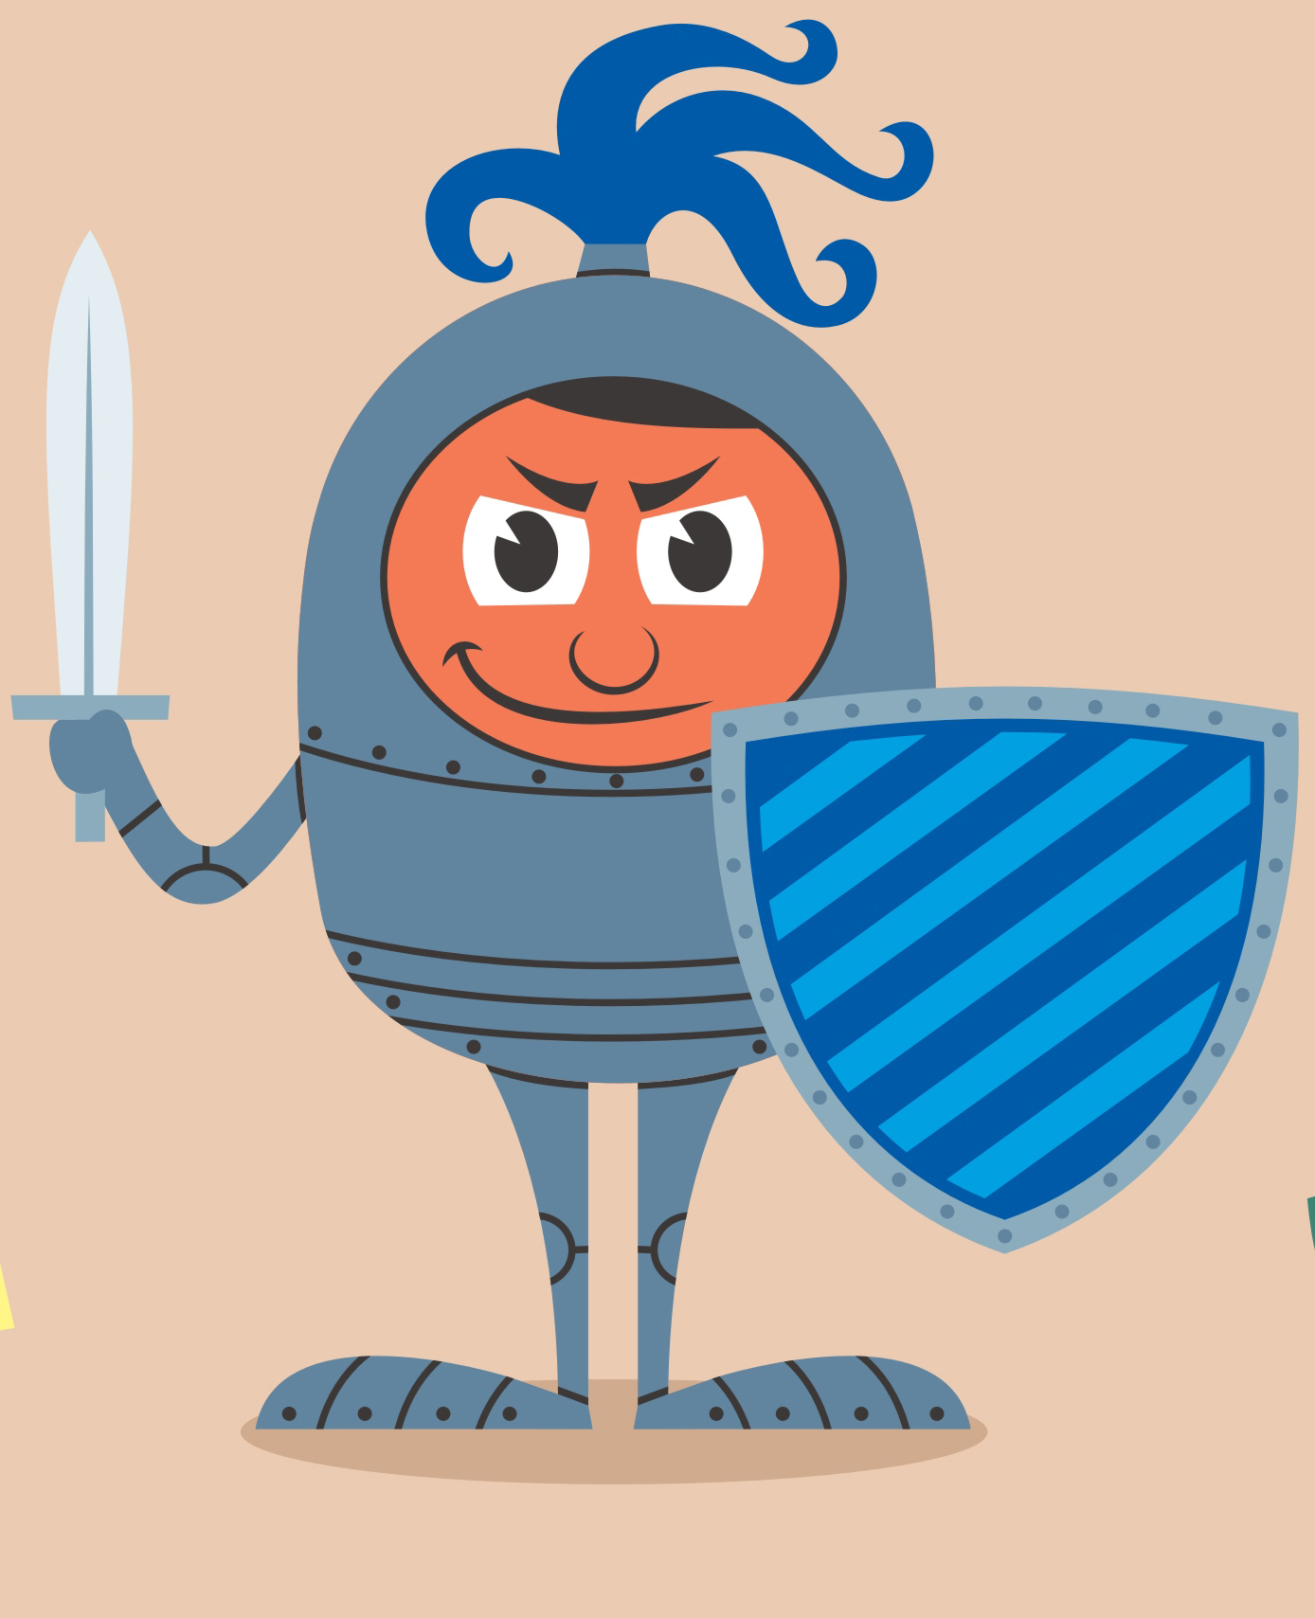
GREEN

ANGRY

SAD

YOUNG

ELEGANT
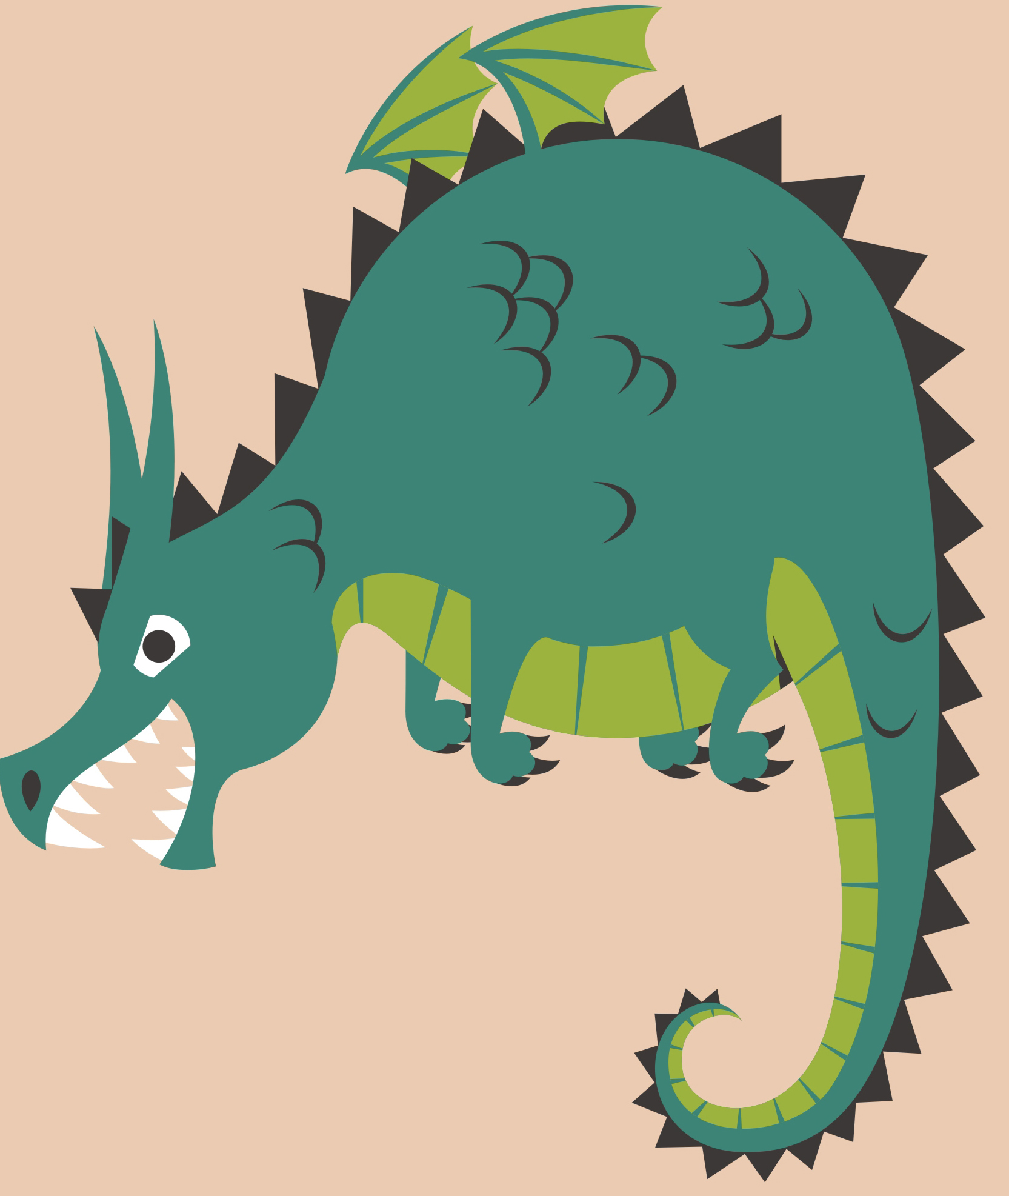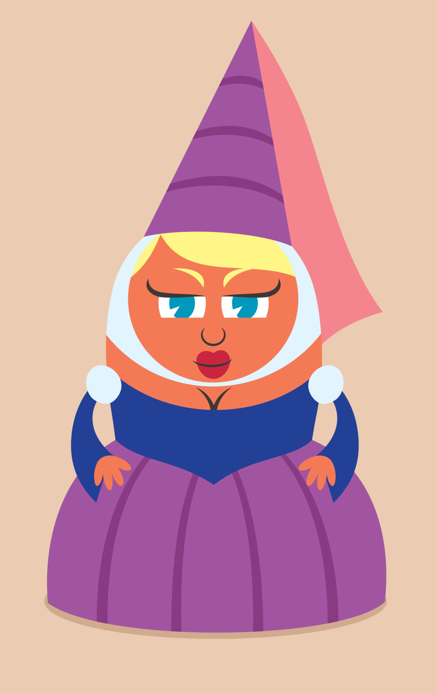

BEAUTIFUL HANDSOME

OLD HUNGRY SCARY

PRETTY POLITE
MAGIC HUGE
KIND

STRONG NOISY

EVIL

CLEVER

DANGEROUS

