FIND YOUR MONSTER!

Write the number of the description under or below the monster it describes!

1. This monster is blue, has three eyes and is smiling.

2. This monster is yellow and has only two teeth.

3. This monster is pink and has only one eye.

4. This monster is red and has fishtails.

5. This monster is orange and it is hairy.

6. This monster is green and has four eyes.

7. This monster is purple and has a long tongue.

8. This monster is blue and has horns.

9. This monster is pink and has six eyes.

10. This monster is blue and has three heads.

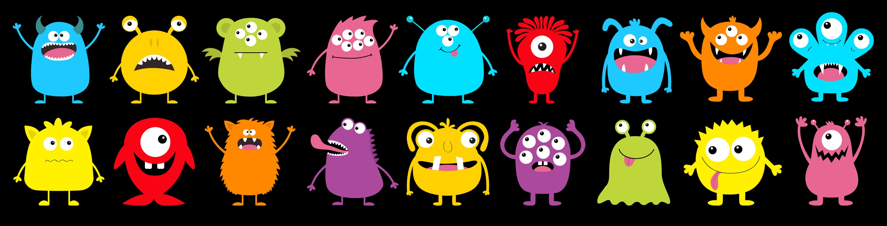
Choose a monster that does not have a description!

Write a description:

.......................................................................................................................

