***Animals***

1 Write the name of the ***young farm animal*** in the picture next to the name of its parent.

1. 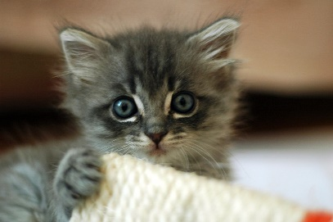 cat – __________
2. 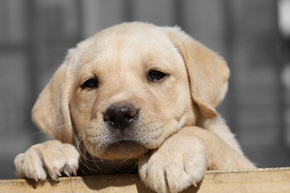 dog – __________
3. 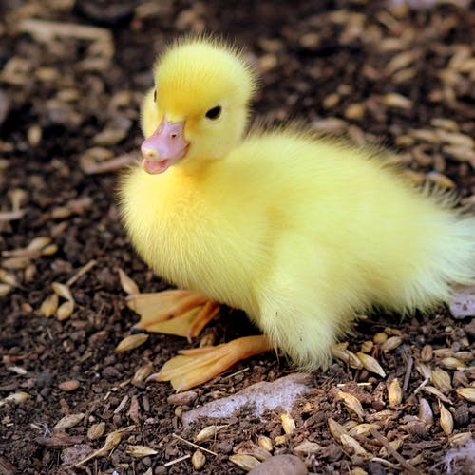 duck – __________
4. 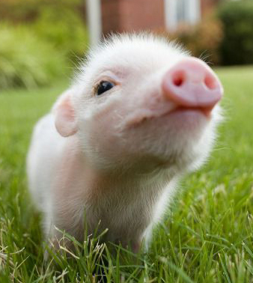 pig – __________
5. 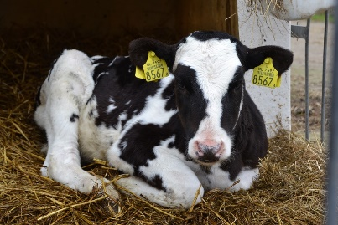 cow – __________
6. 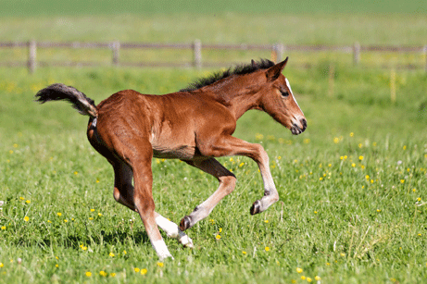 horse – __________
7. 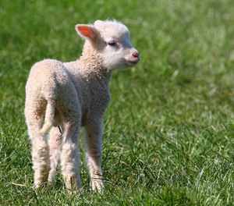 sheep – __________
8. 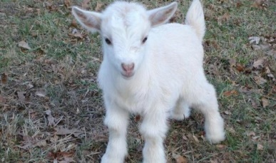 goat – __________

2 Fill in the name of the ***wild animal*** in the picture.

1. f_x 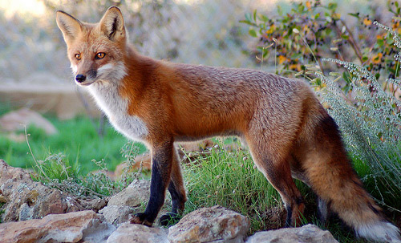
2. _q_i_r_l 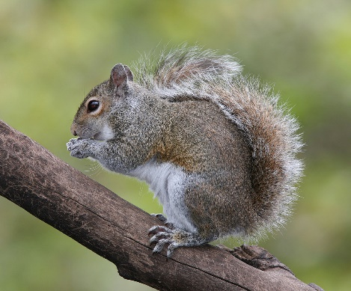
3. f_o_ 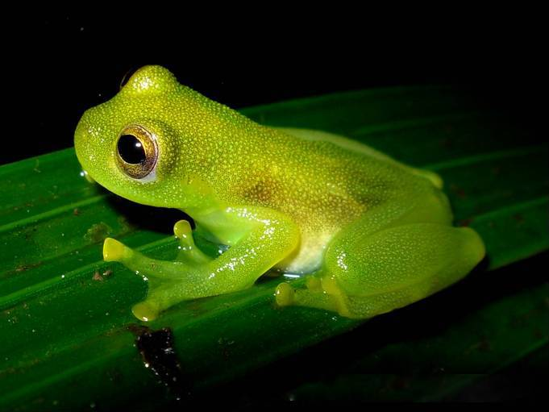
4. _a_l_ 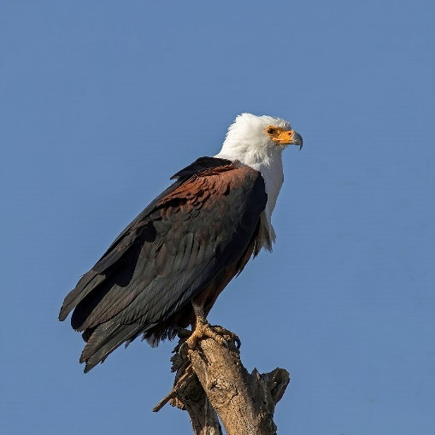
5. s_a_k 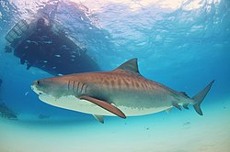
6. _o_f 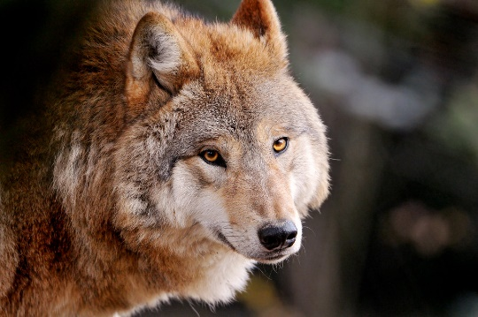
7. i_s_c_ 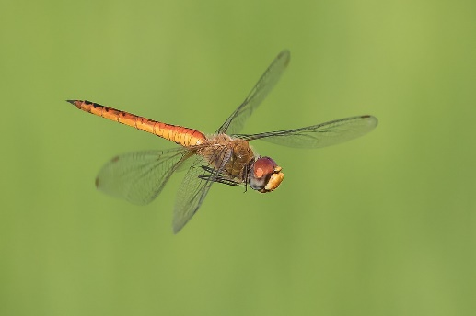
8. _r_c_d_l_ 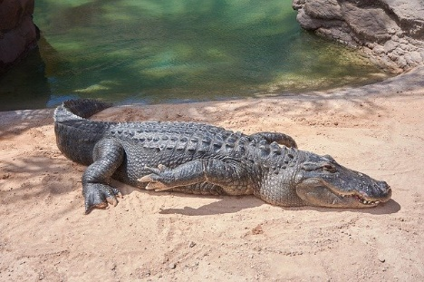
9. m_n_e_ 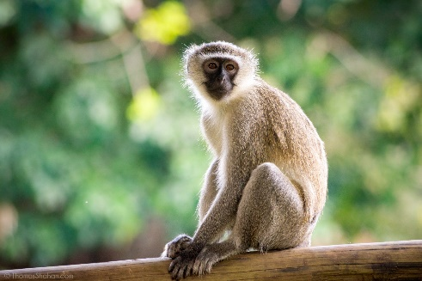
10. _a_ 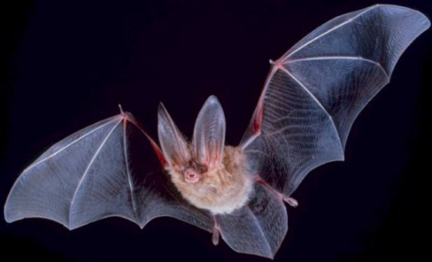
11. _i_e_ 