THE INVENTORY

2. Find the animals in the picture!

mole, ladybird, butterfly, woodpecker, squirrel, mouse, stork, titmouse

.................... ......................... ...........................

.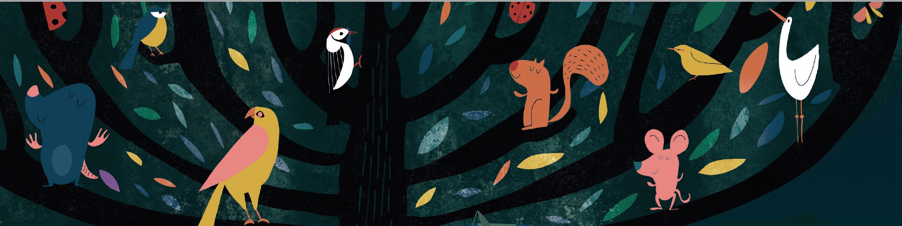

............................ .............................. ..............................

............................... ............................

2. Draw the family tree of the Smiths!

John Smith is 43 years old. He is a dentist. His wife, Emily is 39 and she is a secretary. They have three children. The eldest is Jane. She is 12 years old. The twins are Robert and Frank. They are 9 years old. The children love their grandparents. They often visit Emily’s parents, Rose and William, because they live nearby. John’s father, Edward died a few years ago, and his mother, Mary lives far away, but they often talk on the phone. Emily has a younger brother, Thomas. Thomas is married to Eve and they have a baby daughter, Helen. John does not have any brothers or sisters.

