THESEUS’ SHIP

1. Compare the two pictures!

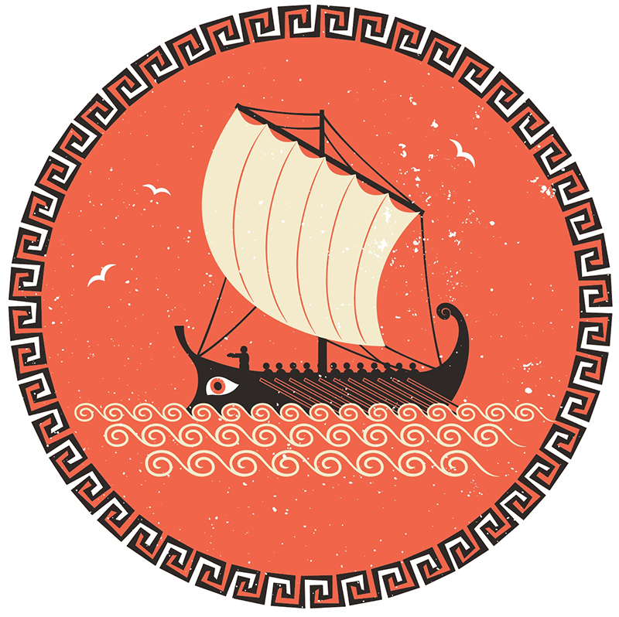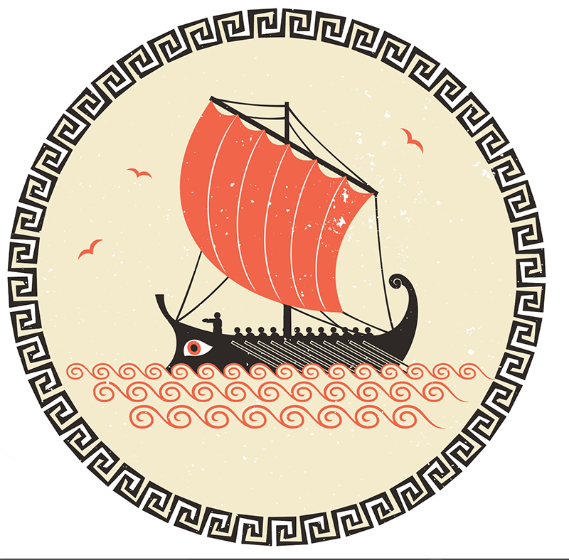

e. g. The first ship’s sail is white, but the second ship’s sail is orange.

––––––––––––––––––––––––––––––––––––––––––––––––––––––––––––––––––––––––

––––––––––––––––––––––––––––––––––––––––––––––––––––––––––––––––––––––––

––––––––––––––––––––––––––––––––––––––––––––––––––––––––––––––––––––––––

2. How many people are there on the first ship? ________________________________

3. Who is the captain? _________________________________

4. Where do you think they are going? _________________________________

5. How many birds are there on the second picture? ________________________________

6. Draw four fish in the water on the second picture!

7. Name both of the ships and write the names on the sails!

