Degas – Picture description

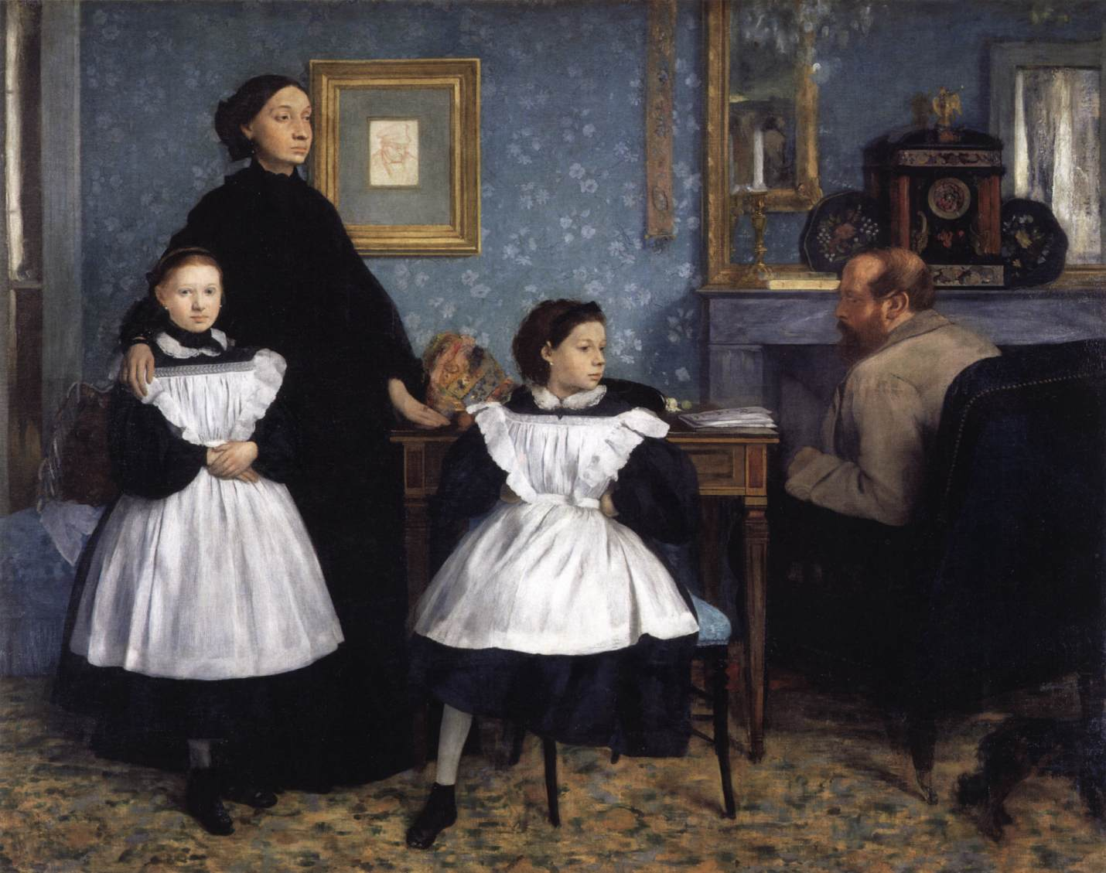

What can you see in this picture?
Describe the room. Name things and colours!
Is this a picture or a painting?
When and where was it made?
How many people can you see? Describe them one by one.
Who are they?
What are they wearing?
Where are they looking? Why?
Guess! What happened?
How do feel? What are your emotions?

Edgar Degas: The Bellelli family

https://www.wga.hu/frames-e.html?/html/d/degas/1/early05.html

