TRANSLATION FROM ENGLISH TO HUNGARIAN

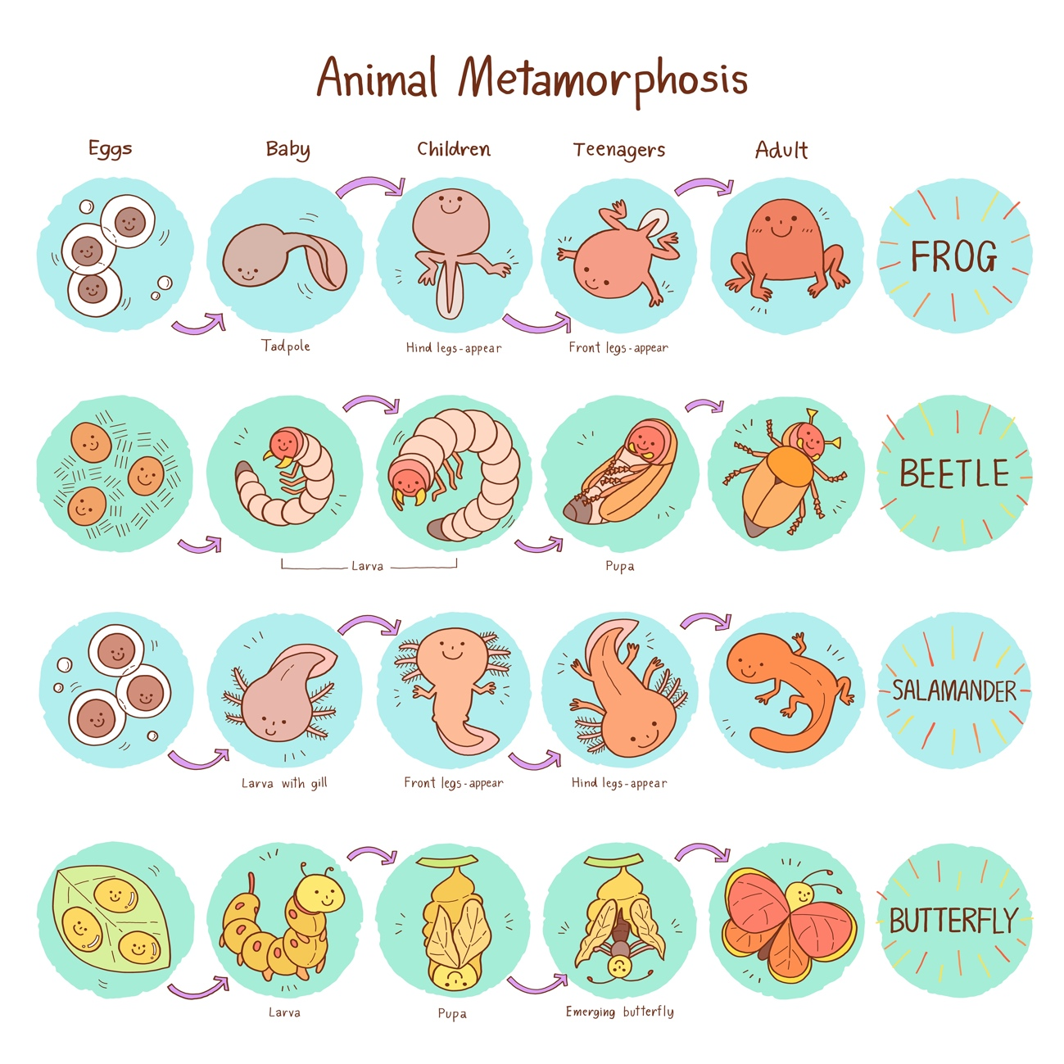

Translate the words to Hungarian and write them on the pictures!

