Picture description

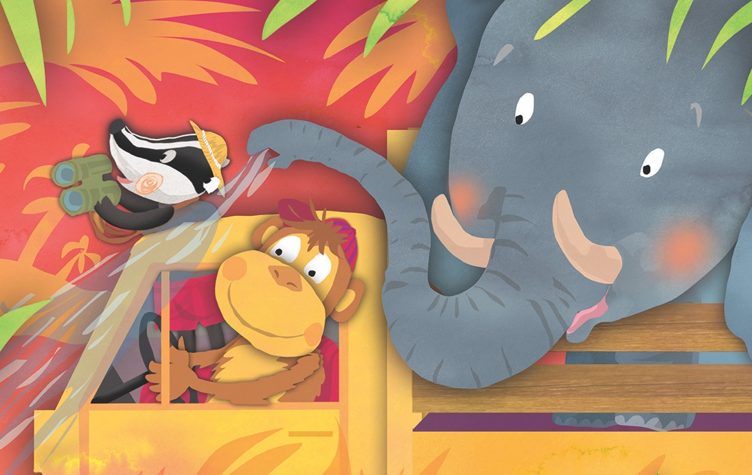

- Look at the picture! Circle the animals you can see!

bird monkey fox elephant badger horse bear

- Who is doing what?

The ............................................. is driving.

The ............................................. is looking into the field-glasses.

The .............................................. is blowing water on the fire.

- What are they doing? Circle the true sentence!

They are travelling in the city. They are fighting the wildfire. They are sightseeing.

- Write 3 sentences about the picture!

.............................................................................................................................................

.............................................................................................................................................

.............................................................................................................................................

