Dürer – Picture description

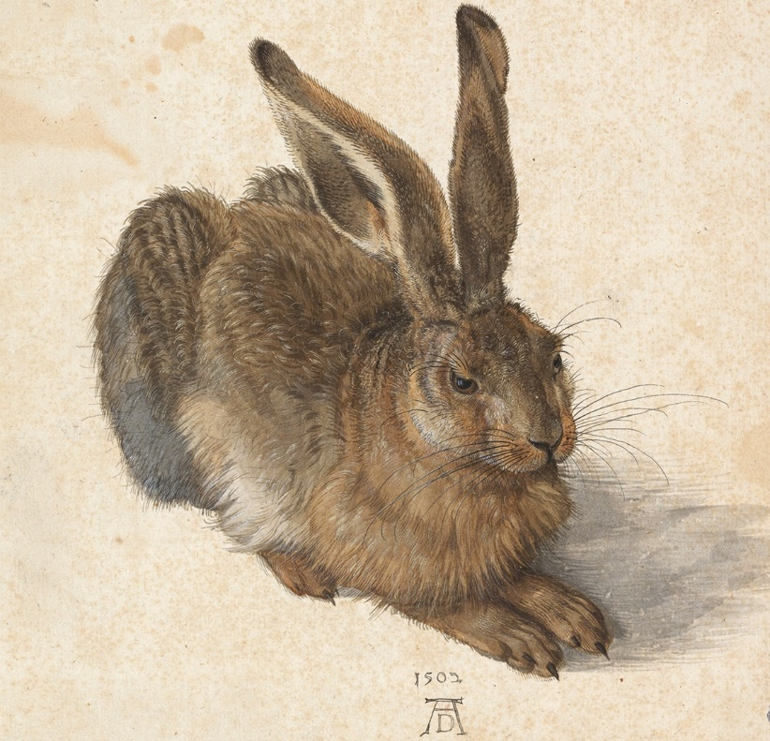

What can you see in this picture?

Describe this animal:
What colour is it?
Name its body parts!
How big is it?
How much does it weigh?
What do you think about its gender?
What type of animal is it?
What does it eat?
Where does it live?
What does it do?
What does it like doing?
How long does it live?
Who has got this at home?
What else do you know about it?

Collect other animal names in 3 minutes!

