Vinci – Picture description

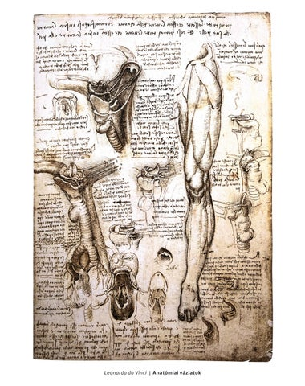

What can you see in this picture?
What is it?
What are these things?
Describe these body parts!
Collect more body parts!

Who made these and why?
What do you know about Leonardo da Vinci?
What else did he do?
Collect more things made by him!

